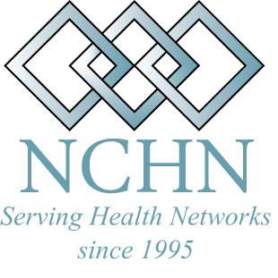
National Cooperative of Health Networks Association

News Release

MEDIA CONTACT: Rebecca Davis, Ph.D., Executive Director RELEASE DATE: April 30, 2010
270-925-5611
RDavis@NCHN.org

LOCAL LEADER WINS NATIONAL AWARD

Larry Matheny, Wilmington, NC -- Outstanding Health Network Leader of 2010
On April 19, 2010, the National Cooperative of Health Networks Association (NCHN) announced their second national award winners during their annual conference in San Antonio, Texas. Larry Matheny, Coastal Carolinas Health Alliance, was selected as the recipient of the NCHN Outstanding Network Leader of 2010.
The Outstanding Network Leader of the Year Award recognizes a network leader with at least five (5) years of experience for leadership in managing a successful health network organization. This award is meant to be inclusive of all types of health networks, alliances, collaboratives, and consortiums. Award winners were nominated and chosen by their national peers.

Larry Matheny has served as President of the Coastal Carolinas Health Alliance (CCHA) since 2005. Since its inception in 1993, CCHA has served not-for-profit hospitals in North Carolina, placing a major emphasis on regional group purchasing contracts. During Matheny’s tenure, savings have gone from $2.3 million to $5.7 million, an average of over an eight to one (8:1) return on investment. CCHA has concentrated on grant writing and has been awarded several grants to develop a mobile simulation laboratory, a Health Information Exchange (HIE) and a regional sexual assault nurse examiner program (SANE). Efforts are underway to fund a community diabetes education program and a LEAN collaborative for southeastern North Carolina.

Prior to coming to Coastal Carolinas Health Alliance, Larry was the Executive Director of the Greensboro Healthcare Network, a physician-hospital, managed care, joint venture, with 330 physician providers and the Moses Cone Health System. He managed several large freestanding and hospital based medical groups in North Carolina and Illinois and was the vice president of a physician practice development company that established medical practices around the country. Larry has more than twenty years of hospital and health system operations experience in the role of Vice President of Operations, Executive Vice President and Senior Vice President in three not-for-profit community hospitals in the Midwest and the Southeast.

“Larry Matheny and CCHA have been an asset to NCHN members,” said Rebecca Davis, Executive Director of NCHN. “He is always willing to share best practices, benchmark data and assist other members in times of need.” In April 2010, Matheny was also elected by the NCHN membership to serve on the NCHN Board of Directors.
By definition, health networks are formed when three or more health care providers formally come together to better meet the needs of patients in their service area. These providers often include hospitals, community health centers, critical access hospitals, physician practices, mental health providers, rural health clinics and other for-profit and not-for-profit health care organizations. These networks work to increase access to quality health care for local patients and streamline the cost of that care, as well.
NCHN is a national level professional membership organization of health network leaders across the nation. Its mission is to support and strengthen health alliances through collaboration, networking, leadership development and education. The Association has members in 33 states. Its major focus in 2010 will be a continued emphasis on supporting Network Leaders across the nation through the expansion of the Executive Coaching Program, ongoing regional conferences and workshops, and the development of a Certification Program for Network Leaders.
For more information please go to www.nchn.org

